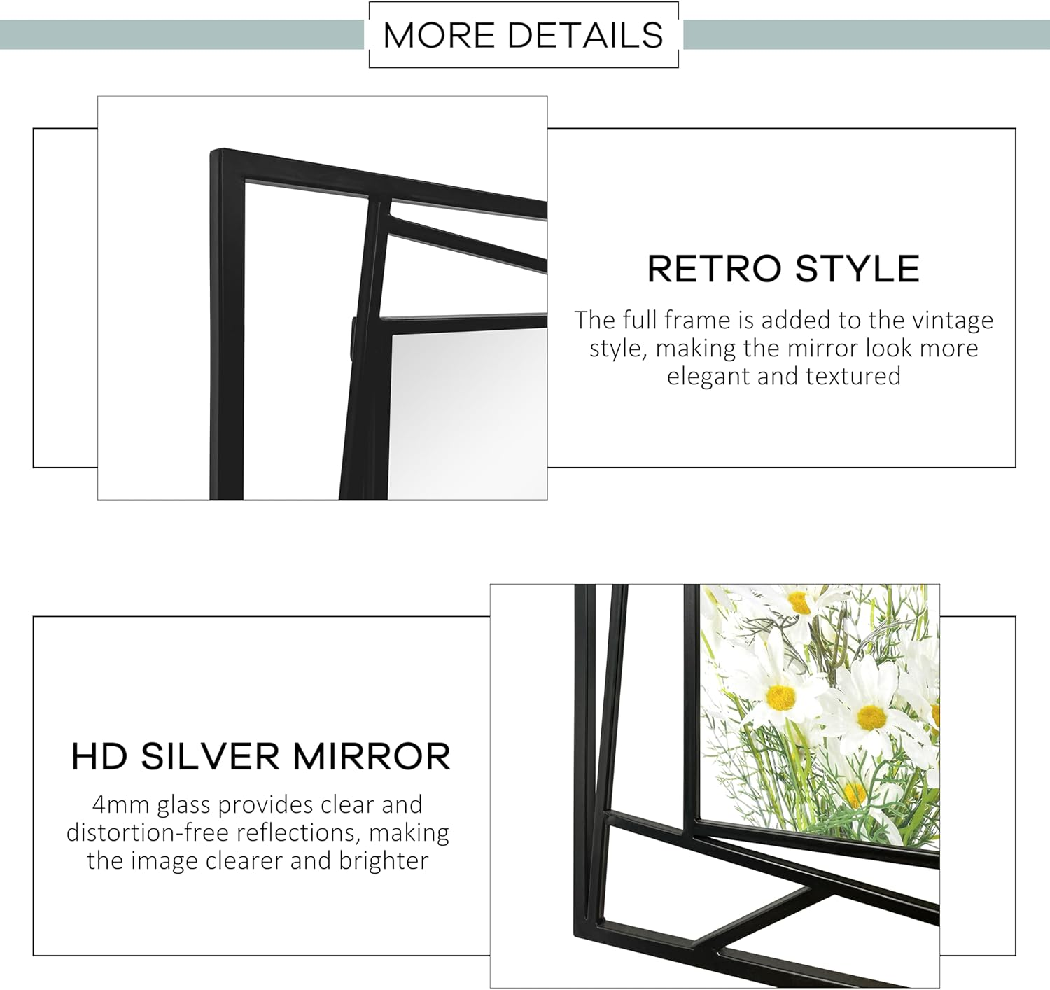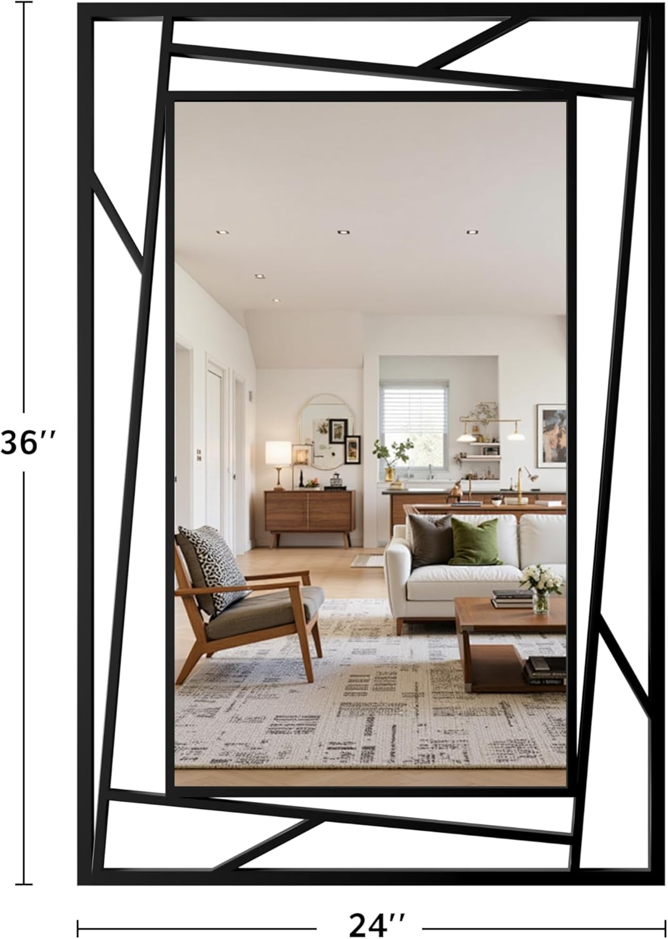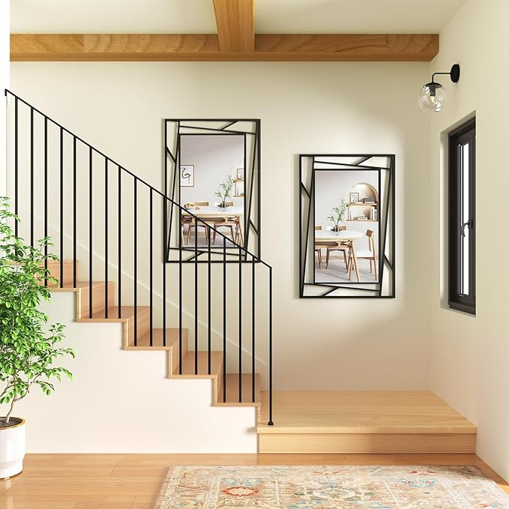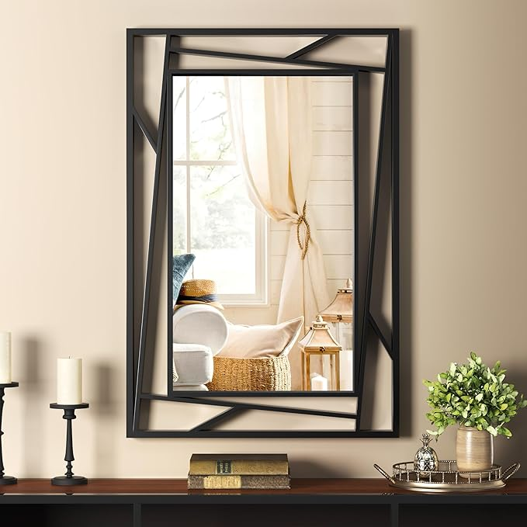

Black Mirrors for Wall Decor, 24"x36" Geometric Metal Frame Decorative Mirror for Living Room, Dining Room, Bedroom, Hallway, Fireplace, Entry, Consoles or Against The Wall

**PRODUCT DESCRIPTION:**

|  |  |
| --- | --- |
| Brand | NXHOME |
| Room Type | Bathroom, Living Room, Bedroom, Hallway, Dining Room |
| Shape | Rectangular |
| Product Dimensions | 36"L x 24"W |
| Frame Material | Metal |

**About this item**

* Large Modern Geometric Wall Mirror: Our 24x36 inch black metal framed mirror features a golden ratio design that enhances the feeling of space. It can be mounted above the fireplace to create a focal point, enhance the sense of light in your living room, and brighten up a narrow entry wall.
* HD Distortion-Free: 4 mm silver-plated glass provides true color accuracy (<0.1% image distortion) for precise makeup application. Anti-fog coating resists bathroom humidity Suitable for use over sink.
* Heavy-Duty Metal Construction: Rust-resistant matte black frame with scratch-resistant coating and interlocking corner seams for structural stability. Oxidation-resistant metal for coastal climates.
* Quick Suspension: Pre-assembled hooks and complete hardware kit with bubble leveling system allow for secure installation in minutes.
* Multi-Scenario Use: Rectangle wall mirrors are suitable for installation in dining rooms, living rooms, bedroom, bathrooms, staircase landings, hallway entryway, consoles, and above mantel surrounds, Or place it against a wall. Its adaptable design enhances the aesthetics of any room while maintaining practical functionality.